--------------------------------Strategy--------------------------------

Client: <https://theramenshop.co.nz/>

**Who is your client:** The client is an award-winning ramen shop which sells food to customers around the Wellington region! “The Best Ramen Since 2013”. They sell region wide either through pick up, eat in or delivery. Located in Newtown, the ramen shop is one of the best ramen joints in Wellington.  
   
Initial SWOT Analysis (<https://theramenshop.co.nz/>):

**Strengths:**

* Easy to find (Order) button
* See all info we need
  + All in one place
  + At the top of the screen / site
* Images are good / relevant (makes clients hungry / want the product)
* Scrolling through the main page shows all info about the company which the user could need.
* Helpful reviews shown on website

**Weaknesses:**

* Pop up - > When you scroll down
* Process is not shown (** Says something about the process of delivery) but takes you to ordering delivery instead of giving relevant information
* Broken links :(
* All information is on main page (links to non-main page is ONLY at top excluding ordering)
* Navigation -> logo does NOT take you back to main page.
* Delivery Option BAD -> not simple and unpleasant experience / process

**Opportunities:**

* More pages to unclutter Main Page
* Making pop ups less annoying and easier to get rid of
* When ordering, the link navigates to a different site -> could integrate it into site directly

**Threats:**

* Broken link may cause user to relook up food online and pick a different website
* Cluttered main page may cause user to leave and find a simpler website
* Pop up stops the user from navigating the page completely and must click the X… User may leave to find simpler website
* When ordering, the link navigates to a different site -> users could use other site to view all competitors and potentially change their minds.

Business needs:

* Sell Product – Food etc.
* Location – Address / Address’
* Displaying contact details
* Displaying Menu (All + Pics)
* Working Links (Not a broken website)
* Simple order process
* Promote business / gain customers
* Responsive to all devices
* Simple website design / not too busy

User needs:

* Easily find:
* Menu (food)
* Contact (Phone) & (Online)
* Address
* Order process to be simple
* Not overwhelmed (Specials etc.)

**Target Audience:**

Primary

Our primary target audience would live in wellington, Newtown as that is where the store is located. We assume they may be 18 – 26, as this is an appropriate age to go out and have lunch / dinner with your friends. Their IT skill level would be high as they are a younger generation and typically younger people are super familiar with tech devices and could order food, look at menus, etc. easily online. They may have low paying jobs and occupations, due to their age, such as students, baristas, checkout people, etc. We assume the customers would have an annual income of 20k –50k due to their low paying occupation as people with higher incomes may choose somewhere more expensive to eat. Ramen can be enjoyed by all cultures, but our primary customers would be of New Zealand descent and from the Asian community.

Secondary

Our secondary audience would be people residing outside of Newtown but still in proximity for either pick up or order delivery. Their ages would be around 23 - 33. This group may have a lower IT skill level as the age goes up, some people can have trouble navigating a website on any device, so creating a website that is super simple, and easy to navigate is important to keep customer flow steady and increasing. We assume these customers may have an annual income of around 40k – 70k They may also have low paying occupations as the ramen at the ramen shop is a cheap food option. However, they may have higher paying jobs as they are a little older and due to may having to purchase delivery further away. Occupations such as a chef, food critics, FOH staff, mystery shoppers, business owners, etc. may be options. The cultures that may enjoy ramen would be cultures who were not included in the primary audience, as anyone can enjoy ramen and New Zealand is a diverse place which holds a lot of cultures and ethnicities.

Competitor Information:

* Restaurants nearby are listed in direct competitors below for biggest competitors.
* Is delivery available – (the ramen shop) Yes through ‘easy delivery’
* Opening hours – (the ramen shop) 12pm -> 2pm & 5pm -> 9pm
* Website aesthetic – (the ramen shop) Simple but all on main page. Scroll type navigation to see all information. Ordering delivery takes you to external website
* See below for the competitors websites information…

Assumptions (Target Audience):

* Many customers are people living in the same region as the restaurant.
* People use mobile devices to look up the website for info on the website for booking, delivery etc.
* New customers will NOT be familiar with the menu and prices
* New customers do not know the open hours
* New customers do not know the contact details
* New customers can find the restaurant on the map
* Customers can order delivery through ‘Easy eats’

Assumptions (Client):

After a brief look into the competition and the client’s websites, we have some assumptions of changes that could be made to help the client compete:

* Fixing dead links, Broken links may cause user to relook up food online and pick a different website
* Clean up the main page, Cluttered main page may cause user to leave and find a simpler website
* Stop website pop up blockers which stop user interaction forcing the user to stop. Pop up stops the user from navigating the page completely and must click the X… User may leave to find simpler website
* Split the content into subpages instead of having all info on ONE page. More pages to unclutter Main Page

| Direct Competitors | <https://www.origami-nz.com/> |

| <https://tjkatsu.co.nz/> | <http://noodlecanteen.co.nz/> |

Competitor analysis

| <https://www.origami-nz.com/> |

Is delivery available – Yes through deliver easy && uber eats  
Opening hours – 11:30am -> 9:00pm

**Strengths:**

* Easily order online
* Image on founding the landing page
* They do have contact information but is ONLY phone number for booking.
* Images represent food well -> (Really good images)

**Weaknesses:**

* Late pop-up jumps at user
* MISSING IMAGES
* NOT A CLEAR IMAGE
* Some things are hard to read (Colour scheme)
* Random ‘X’ On page (more than once)
* Random dark blue box at bottom under image (Colour scheme)
* Menu page takes long time to load...
* Missing images on menu (incomplete)

**Opportunities:**

* Possibility to implement online food ordering system (pickup)
* Nice looking website, bad functionality with many issues around website -> easy to make a website improvement.
* Information is not delivered clearly, could be improved with UI remake.
* Menu (submenus) are not clear (buttons)

**Threats:**

* Some images are hard to read as well -> may deter user to easier website
* Text BAD colour (barely readable) -> may deter user to easier website
* Delivery and Menu Button do NOT stand out enough (missed it multiple times)

| <https://tjkatsu.co.nz/> |

Is delivery available – Yes through deliver easy && uber eats  
 Opening hours – 11:00am -> 7:00pm

**Strengths:**

* Easily order online
* Displaying Menu (allspices)
* Location \Address
* Different type of food variety
* Contact details
* Home and Phone number stick out from other buttons
* Menu split into TWO types -> lunch specials and full menu

**Weakness’:**

* links (not working)
* Images are too large (not loading fast and use lots of data)
* Main page has LONG loading time.
* Poor choice of wording -> “staff ‘USUSALY’ friendly” …
* Top navigation menu does not stay shown (scroll)
* Annoying animation when mouse over button
* Buttons to change the slide do not work.
* Info dump on main page (too much to read)

**Opportunities:**

* Good systems for online food delivering
* Promote business (gain customers)
* Make main page simpler to attract more customers with an easy-to-use website
* Reduce image sizes and optimize website to make loading faster for users
* Keep menu (navigation) shown even when scrolling

**Threats:**

* Some images are not a proper definition about that food.
* Website not optimized (long load time) -> may deter user to faster website
* The less straightforward design is harder to follow which may deter users from website

| <http://noodlecanteen.co.nz/> |

Is delivery available – Yes from UberEATS (NOT shown on website)  
 Opening hours – 11:00am -> 10:00pm

**Strengths:**

* Good menu displayed on menu page
* Menu is easy to navigate
* Map of locations easy to use, simple to understand + a full list of each store on different page
* Effective use of colour and contrast

**Weakness’:**

* Website takes long time to load
* Single Button (contact) -> bad contrast
* Stars under each menu item overwhelming
* One of the links is not properly linked (broken link)
* Bottom footer has bad moving text… (ugly)
* About us has no contact info, only background info
* No prices on menu items
* Looks old (not modern)

**Opportunities:**

* Modernizing the website and making it simpler etc. –> Could improve the website traffic and encourage users to use it.
* Decrease image sizes to optimize website
* Fix links -> working navigation
* Add a contact us button or something in the about us to navigate user to information they may want?
* Add prices to items -> shows users what they get for price, instead of looking elsewhere with items with prices on them on anther website.
* Modernize the website to attract users to the fresh look and feel which could make the user more engaged and less deterred from the old website look / feel.

**Threats:**

* Website is NOT secure meaning when you place an order through their website, you are at risk of giving away personal data / information -> might deter customers…
* Old style website (not modern) may deter users to other more modern websites
* Broken links may deter users to easier website
* Ordering online is not simple (no obvious button) (not easy to do)

Inspiration

“Inspiration. Not necessarily from a competitor, but websites or companies that display their UI and guide their user well should be taken as inspiration.” – Jacob suggested a mood board with things that inspired our ideas for website like adding screenshots of other websites etc. –

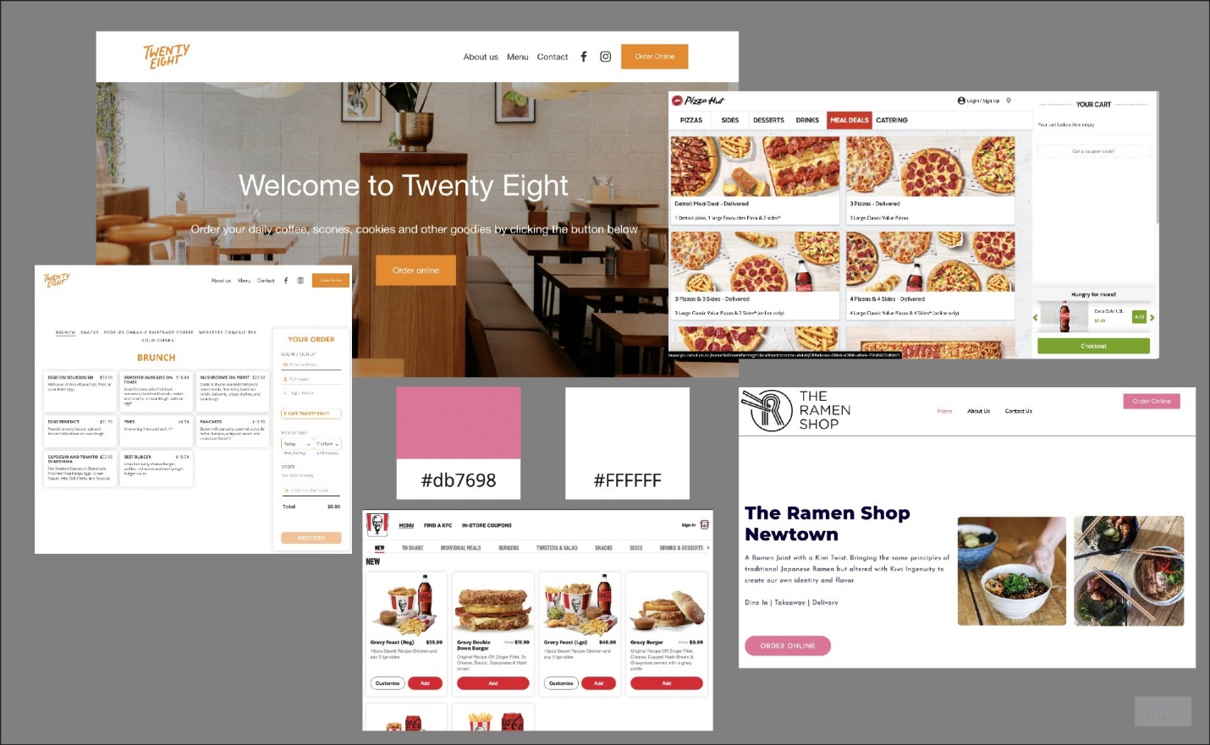

--------------------------------Research-------------------------------

Conduct research to find out if your assumptions are true, as well as any additional info.

Research will be collated into a set of pages that document (Example on Blackboard):

* Tasks for the user to complete when you observe them using the websites
* Observations when a real user tries the website
* Qualitative, open questions asked to the user after they test the website, and their responses
* Quantitative, closed questions given to the user in a Survey, via Survey Monkey.

**Tasks:**

* “Can you find the physical address / location of the store?”
* “Can you attempt to order online any item of food **Don’t actually”
* “Can you find the contact information to ring the store?”
* “When does the Ramen Shop open / close today?”
* “Can you find the price of the ‘chicken rice bowl’?”
* “Can you find out when the Ramen Shop first opened?”
* “Can you attempt to go to the home page -> From contact us page”

**Observations:**

Difficulties the user has:

|  |  |  |  |  |
| --- | --- | --- | --- | --- |
| The menu was difficult to navigate, too much going on, busy. | Finding the chicken rice ball was difficult for most as the menu was quite busy, users said that if they were not already familiar with the website it would have taken much longer to find | User attempted to click the logo to return home only to find it did not work | Going back to the home page from the menu seemed to be a struggle for most of our user testers | The hours section has been laid out weird and can be confusing |

Pleasant experience the user has:

The subtitles in the menu are useful in identifying the category the user wants to look through

The About page is truly clear and informative.

User misses necessary or obvious UI:

|  |  |  |  |  |
| --- | --- | --- | --- | --- |
| No one clicked the main logo to go home but when asked all assumed it would take you home | Null | Null | Null | Null |

**Open Questions:**

“In your own words, describe how easy you found finding the address of The Ramen Shop”

|  |  |  |  |  |
| --- | --- | --- | --- | --- |
| Pretty easy, click the about us button for all information on the store. | It was logical. You expect the address to be on an easily read contact page. | Pretty easy, it was where I would expect it to be | Extremely easy, only one click | The address was easy to find due to being under the contact us page |

“What is your opinion on the colours of the website?”

|  |  |  |  |  |
| --- | --- | --- | --- | --- |
| Like pink is soothing/soft feel like it needs a little more, feels empty | Simple, brand is not iconic/obvious. | Exceptionally clean and minimalistic, quite modern, still retains a personal feeling somehow | Simple, minimalistic. | Colours are all good they seem to relate to the illustration on the shop wall. Although the pink text is hard to read |

“What did you find helpful or inconvenient about the website?”

|  |  |  |  |  |
| --- | --- | --- | --- | --- |
| Inconvenient, pop ups, long main page, directory does not follow you as you scroll. Convenient nav buttons simple self-explanatory. | It was easy to navigate from the home page. However, once I had ordered it was hard to return home. | Main website was great but having the ordering on a completely different address was legally Jank. | Everything is one click away and it is extremely easy to navigate around, less than 10 clicks to find anything you need to know. | Navigation is very inconvenient. Images are helpful as you can get an idea of the store environment and what the food looks like |

“Do you like the layout / design of the website? Why?”

|  |  |  |  |  |
| --- | --- | --- | --- | --- |
| Like symmetry, well defined contrast between buttons. overall, yes, I like it | I do like simplicity. I do not care about anything except getting my food. | Yes, the main page is clean and approachable, although the ordering page was made by a different company entirely, and it shows; does not show well either. | Yes, it is simple and clean. Does not show an overwhelming amount of info and keeps the user at ease. | Like the simplicity of the layout as do not feel cluttered with information |

“What was it like to navigate around the website? Why?”

|  |  |  |  |  |
| --- | --- | --- | --- | --- |
| Easy, apart from main page too much scrolling, | It was overall logical and easy. Food is all that matters. | It was reasonable and convenient; things were not more than one hyperlink away for the most part | Convenient and efficient. There are not a lot of options on the website. | It is good to navigate when scrolling but exceedingly difficult and confusing when trying to navigate to ordering food |

“What was something you liked about the website? Why?”

|  |  |  |  |  |
| --- | --- | --- | --- | --- |
| Colours, relaxing/chill.  Images looked nice. | I liked the easiness of access and simplicity because I only care about the food. | I like pink. It is unique | How simple it was and effective.  I love ramen (: | Like the imagery of food, due to being able to see what I will be eating |

**Survey:**

https://forms.gle/ATYnpBfLpFYXw6wU8

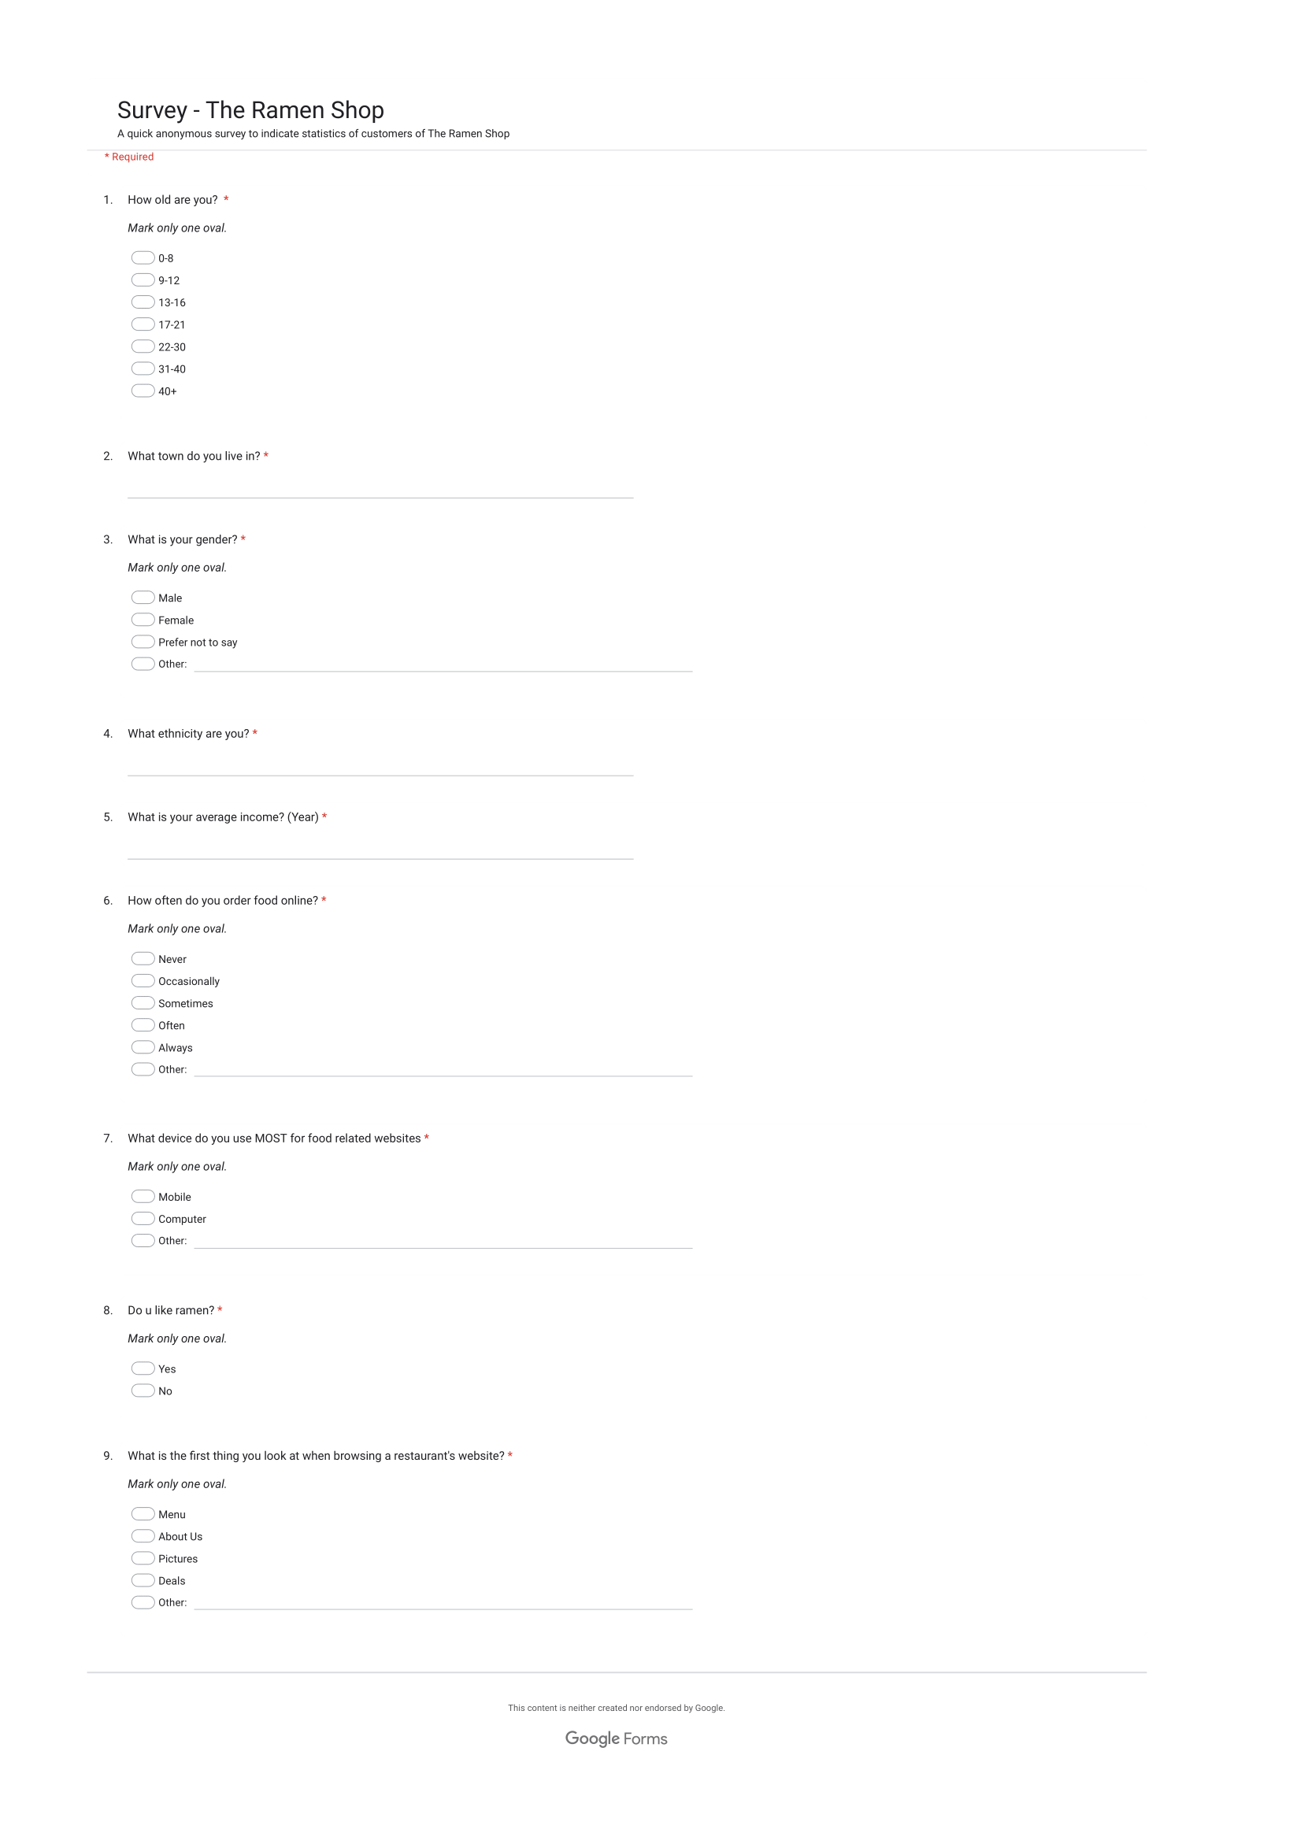

** Zoom In to see survey (:

--------------------------------Analysis--------------------------------

**Collected Data:**

Observations: From our observations the ordering page / menu was difficult to navigate around because there was too much for the users to see at once. This was evident when we asked the users to find a specific item on the menu where one person completely missed it as they navigated over it. This is something we will take into consideration for the new website.

Users attempted to click the logo to return to home page which wasn’t implemented in this website. This is an assumption customers make that the logo at the top would return you home. This is something we will implement into the new website.

Users struggled going back to the main page from the menu and was described afterwards as a very unpleasant experience. This is something we intend to fix in the new website.

Users found the store hours laid out as hard to read and were hesitant about the store hours. We will make it simpler and easier to read in the new website.

Open Questions:

“In your own words, describe how easy you found finding the address of The Ramen Shop” - The research showed us that the users found it easy to find the address under the contact page and about us page, both one click away. This made it simple for the users to navigate to the information they were trying to find because it was in a place, they expected it to be.

“What is your opinion on the colours of the website?” - The research showed us that users all like the colour palette for the website and how it was used. It was ‘original’, ‘relates to the illustration on the shop wall’ and ‘soothing/soft feel’. However, there are some changes that can be made from our research -> ‘pink text is hard to read’ - we will change the text (buttons on headers) to be readable colours. On the main page ‘it needs a little more, feels empty’ we will put more content which is relevant to reduce the white space while still maintaining that clean look. ‘I like pink. It is unique’

“What did you find helpful or inconvenient about the website?” - From this question in our research we can find pros / cons which the users liked/disliked indicating what to keep/change for the new website. Things that were inconvenient which we will either remove / change include: pop ups (remove), long main page (shorten), nav bar disappears when you scroll (needs to stay shown), ordering on a different page / website completely (build into website) and process to return to home from ordering (make easier). Things that were convenient which will be bought to the new website which users liked include: Images are helpful as you can get an idea of the store environment and what the food looks like, everything is one click away and it is extremely easy to navigate around, it was easy to navigate from the home page and convenient nav buttons simple self-explanatory.

“Do you like the layout / design of the website? Why?” - There were a lot of comments about what users liked which we will bring to the new website. This included: symmetry, well defined contrast between buttons, simplicity, clean and approachable and does not show an overwhelming amount of info and keeps the user at ease

“What was it like to navigate around the website? Why?” - Easy, apart from main page too much scrolling (we will shorten main page), It was reasonable and convenient; things were not more than one hyperlink away for the most part (will keep the simplicity of navigation and logical links etc.) and exceedingly difficult and confusing when trying to navigate to ordering food (will rebuild food ordering into website directly).

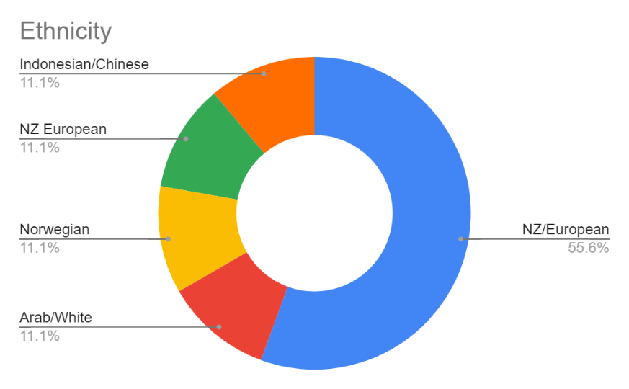

The data gathered indicates most of the customers who took the survey are NZ/European, however also indicates overall that the customers who took the survey are a diverse group of many ethnicities.

The data gathered here is inconclusive as most of the customers who took the survey stated they were male or clicked other/prefer not to say. We can see however that at least half of the customers who took the survey are male.

The age range indicated from the survey is most of the customers who took the survey are aged between 17-21 and then 22-30. This gives us an age range between 17 – 30 of most customers who took the survey.

The data we collected indicated about a third of customers who took the survey used their phones, another third used their computers and the rest used both, indicating a 50/50 split between customers who took the survey would use their phones vs a computer.

The results for this were very mixed. Most customers who took the survey ‘sometimes’ order food online. The rest were quite mixed however and were inconclusive, but it’s clear from our research that most customers who took the survey order food online with hardly anyone never ordering food online.

The results from our survey indicate most of the customers who took the survey reside in the wellington region and the rest in a neighboring region. This makes sense as the only restaurant of The Ramen Shop is in Wellington region.

From our survey we asked customers to tell us what the first thing they do when looking at a restaurant website and most customers who took the survey indicated that they look at the menu. This is good to know as we can incorporate this consideration into our design. The current website for the ramen shop does not have a clear and straightforward way to navigate to the menu.

From our survey most of the customers either did not know their income or did not have an income. This would indicate that most customers are always looking for a special / good deal to save on costs and so we may incorporate this idea into the website design.

**Define 3 Client Personas:**

**Re Assumptions:**

“““  
Assumptions (Target Audience):

* Many customers are people living in the same region as the restaurant.
* People use mobile devices to look up the website for info on the website for booking, delivery etc.
* New customers will NOT be familiar with the menu and prices
* New customers do not know the open hours
* New customers do not know the contact details
* New customers can find the restaurant on the map
* Customers can order delivery through ‘Easy eats’

Assumptions (Client):

After a brief look into the competition and the client’s websites, we have some assumptions of changes that could be made to help the client compete:

* Fixing dead links, Broken links may cause user to relook up food online and pick a different website
* Clean up the main page, Cluttered main page may cause user to leave and find a simpler website
* Stop website pop up blockers which stop user interaction forcing the user to stop. Pop up stops the user from navigating the page completely and must click the X… User may leave to find simpler website
* Split the content into subpages instead of having all info on ONE page. More pages to unclutter Main Page

”””

From our data collected in our research we can conclude that the assumptions are accurate:

**Many customers are people living in the same region as the restaurant** – This assumption is accurate because the data collected from our research indicates that most of the customers who took the survey are living in the Wellington region or close to it (77.8% said wellington).

**People use mobile devices to look up the website for info on the website for booking, delivery etc. –** This assumption was wrong because the data we collected indicated about a third of customers who took the survey used their phones, another third used their computers and the rest used both, indicating a 50/50 split between customers who took the survey would use their phones vs a computer. It was wrong to assume most of the customers used their mobile device.

**New customers will NOT be familiar with the menu and prices** – From our research, the new customers that were interviewed were not familiar with the menu prices and needed to navigate to the menu / ordering page to find the prices. Our assumption therefore is accurate and will remain true unless any new information presents itself.

**New customers do not know the open hours** – From our research (interviews) we found that our new customers didn’t know what the opening hours were but found them easily due to the simple and logical navigation meaning our assumption was correct and we will make sure that the information is easy to find.

**New customers do not know the contact details** – From our research (interviews) we found that our new customers didn’t know what the contact details were but found them easily due to the simple and logical navigation meaning our assumption was correct and we will make sure that the information is easy to find.

**New customers can find the restaurant on the map** – From our research (interviews) we found that our new customers easily found the map / address of the restaurant on the website so our assumption is correct, and we will make sure the information remains available in these places for new customers on the new website.

**Customers can order delivery through ‘Easy eats’** – This assumption is incorrect since the website is NOT kept up to date. Deliver eats website which the hyperlink brought us to doesn’t work and customers can NOT order through deliver eats. When we make the new website, we will make sure the delivery option is functioning correctly.

**Fixing dead links, Broken links may cause user to relook up food online and pick a different website** – We asked customers in a survey if they would go to a different website if links were broken and most customers who answered the survey said they would go an easier functioning website. Our assumption is correct and so when we create the new website, we will do thorough testing of the website to ensure all links work as intended.

**Clean up the main page, Cluttered main page may cause user to leave and find a simpler website** – We asked customers in a survey if they would go to a different website if the website was overwhelming / complicated and most customers who answered the survey said they would go an easier functioning website. Our assumption is correct and so when we create the new website, we will make sure the new website maintains a simple, modern and logical look/feel.

**Stop website pop up blockers which stop user interaction forcing the user to stop. Pop up stops the user from navigating the page completely and must click the X… User may leave to find simpler website** – From our research (interviews) we found that everyone who was interviewed complained about the pop up and agreed with our assumption. We will ensure the new website does NOT include pop ups. (:

**Split the content into subpages instead of having all info on ONE page. More pages to unclutter Main Page** – The main page is very long, and our research indicates that the main page was too big (to scroll) so our assumption was correct. Although it was not cluttered, the main page content can still be split into subpages as our assumption is correct. **Card Sorting:**

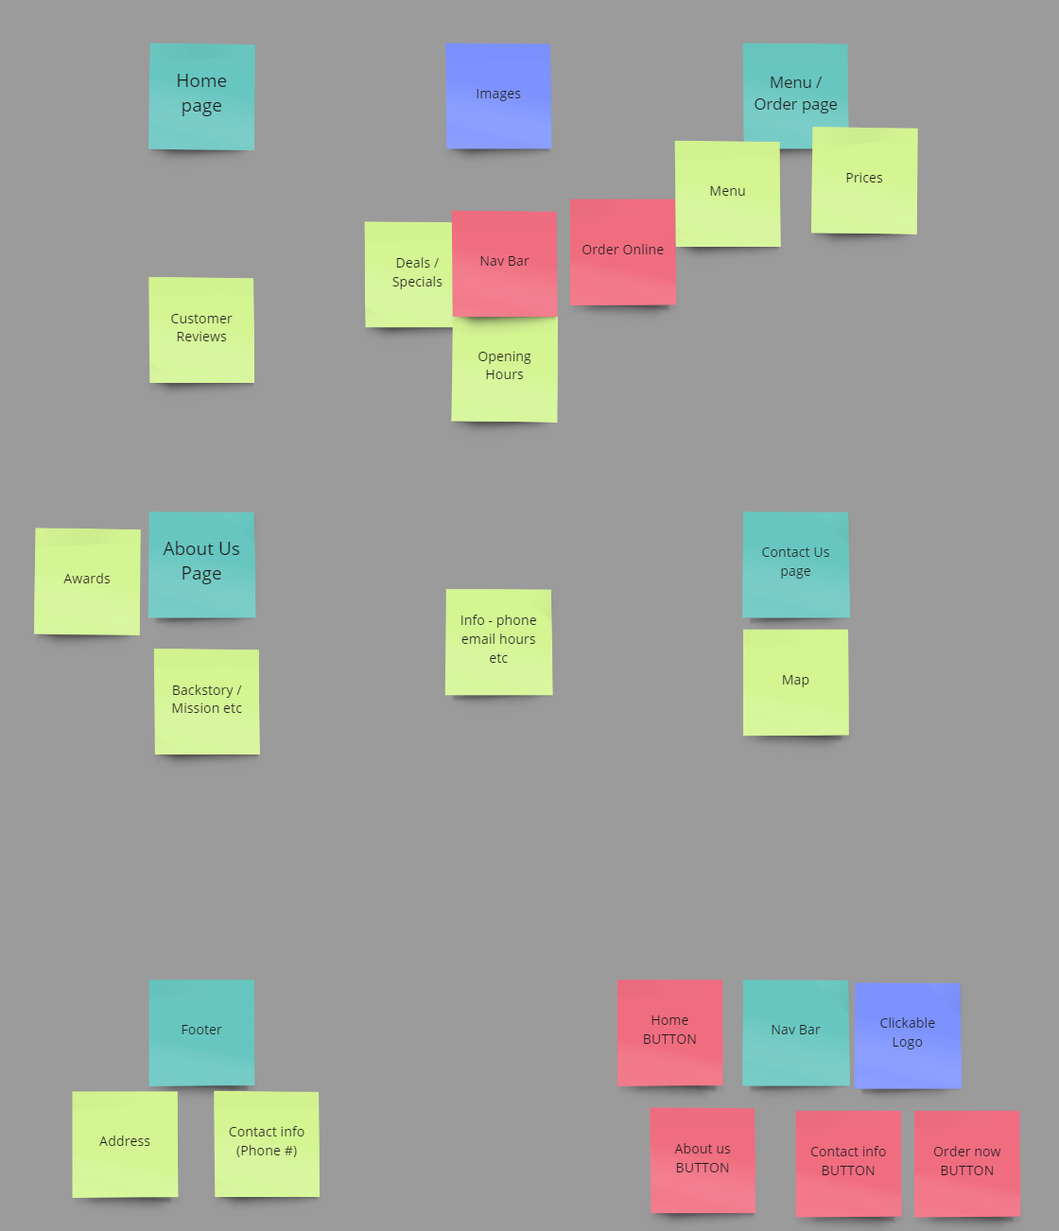

------------------------------Style Guide-------------------------------

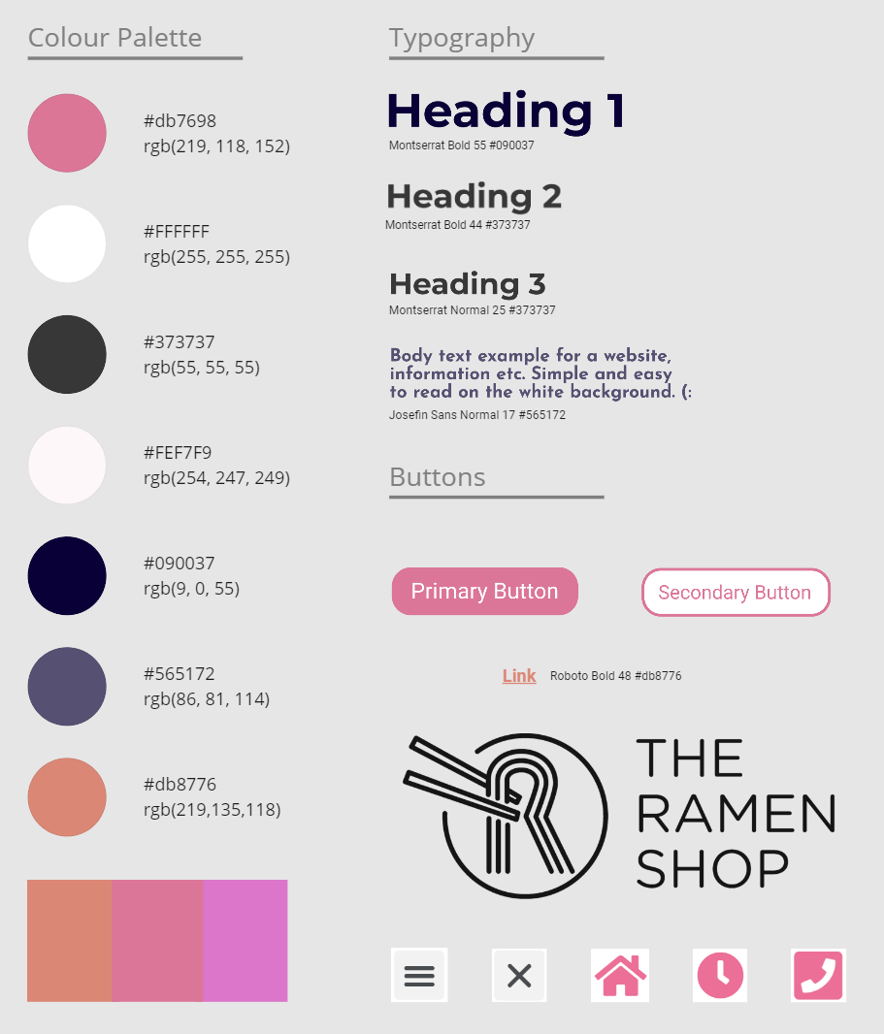Explanation:

All colours and Typography were taken from the ramen shop to keep the simplistic design. We added #db8776 for links to make it easier to see the links. This is the complementary colour of #db7698 and looks good in the style guide. All images / icons were also taken from the original website as they worked for their design, so we are reusing them.